1. Class Diagrams

|  |  |
| --- | --- |
|  | League |
| - | teamList : String |
| - | leagueName : String |
|  |  |
| + | getTeam() |
| + | getLeague() |

|  |  |
| --- | --- |
|  | Game |
| - | location : String |
| - | nameTeamA : String |
| - | nameTeamB : String |
| - | scoreTeamA : Int |
| - | scoreTeamB : Int |
|  |  |
| + | getLocation() |
| + | getTeamA() |
| + | getTeamB() |
| + | getScoreA() |
| + | getScoreB() |

|  |  |
| --- | --- |
|  | Team |
| - | nameTeam : String |
| - | playerList : String |
|  |  |
| + | getTeam() |
| + | getPlayers() |

|  |  |
| --- | --- |
|  | Player |
| - | namePlayer : String |
| - | numberPlayer : Int |
| - | positionPlayer : String |
|  |  |
| + | getName() |
| + | getNumber() |
| + | getPosition() |

|  |  |
| --- | --- |
|  | Goal |
| - | distance : Int |
| - | openPlay : Boolean |
| - | numberPlayer : Int |
|  |  |
| + | getDistance() |
| + | getOpenPlay() |
| + | getNumber() |

1. The Player class has 3 properties, which consists of namePlayer, numberPlayer and positionPlayer.
2. All three properties and method in Player class are public.
3. Aggregation: League object has Team object inside it, while Team object has player Object inside it.
4. Communication diagram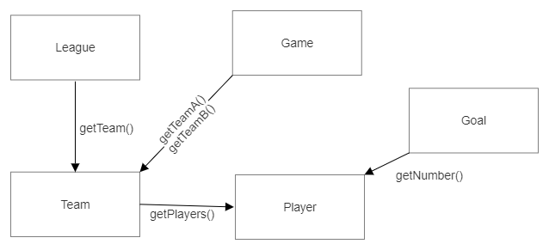
5. Activity diagram

